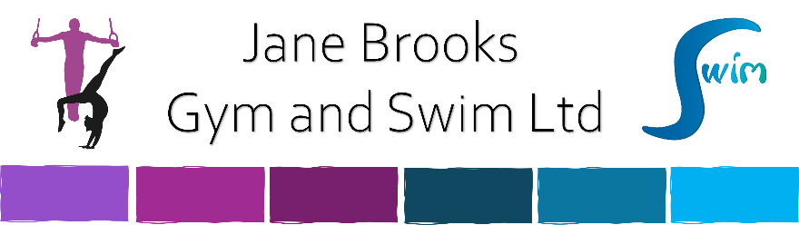

Term and Conditions for Jane Brooks Gym and Swim Ltd.

☐ I agree to the terms and conditions attached to each invoice specific to the location and activity (Swimming and/or Gymnastics) that my child attends.

☐ I agree to disclose all relevant information regarding my child’s health, development and needs where applicable.

☐ I agree to inform you of any long periods of absence or if my child is leaving the swim school or gymnastics club.

☐ I agree to keep my contact details up to date.

☐ I agree to the following Payment Terms and Conditions:
1. Upon registration with Jane Brooks Gym and Swim Ltd, an account will be created for the purposes of invoicing session fees. Siblings will appear under the ‘family’ account but will appear on separate invoices.

2. Jane Brooks Gym and Swim Ltd is VAT registered and VAT is included in our class fees.

3. Invoices are produced as soon as a member is allocated onto a course and will be sent out via email unless otherwise specified. At the end of each term, a new invoice is created and sent for the following term as part of our re-enrolment process.

4. The invoice includes all the available sessions for that term which are listed in date order.

5. Invoices are payable before a members second lesson if they are new members; otherwise they are to be paid before the start of the course.

6. We DO NOT charge for sessions that WE cancel. Where cancelled sessions do happen, a credit or refund will be issued to your account.

7. We DO charge for available sessions that YOU do not attend. We do not offer refunds or credits for unattended sessions. This includes deciding to leave the course mid-term even though fees are paid in full at the start of term. We require half a term’s notice if you decide you no longer require a place.

8. Lessons cancelled due to any circumstance beyond our control i.e. Snow, Flooding, etc will result in a 50% refund for the lesson missed.

9. Credits will appear on the following terms invoice.

10. Payment is via Direct Debit (through GoCardless). You will be sent a link to authorise the direct debit with the invoice. We are unable to accept credit or debit cards, or accept any form of childcare vouchers. Fees are collected on a half-termly basis.

11. Accounts that are not paid in full by the last week of the term will be subject to a Late Payment Fee (L.P.F.) as published - currently £10 per member.

12. We operate a Debt Recovery Procedure in partnership with HM Courts Service and pursue ALL outstanding debts. The costs incurred in this procedure will be added to the final account balance. Accounts that are not paid in full after 4 weeks into the consecutive term will be automatically referred for debt collection without any further warning or communication

